|  |
| --- |
| C:\Users\user\Desktop\Draktsho logo.jpg |
| Draktsho Vocational Training Centre for Special Children and Youth |
| **Annual Report 2022** |
|  |

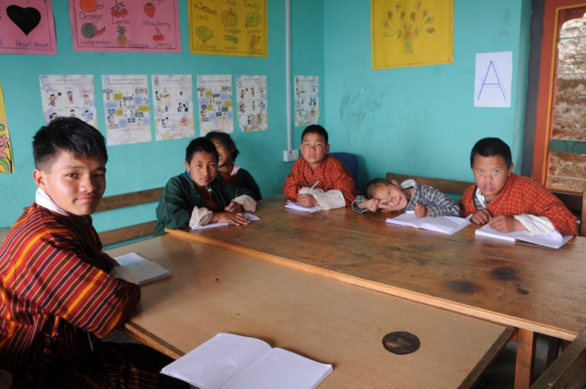

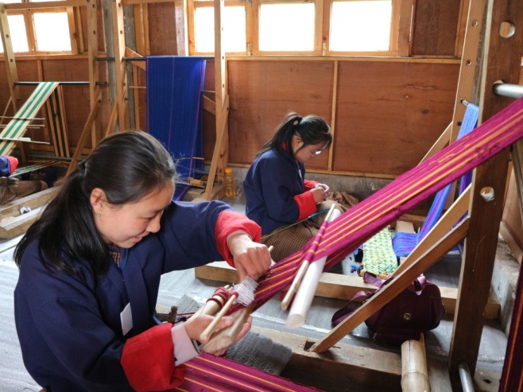 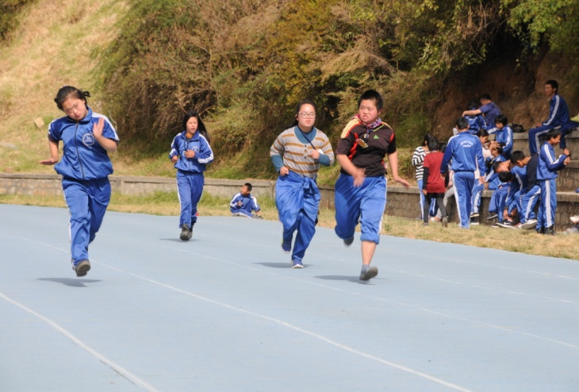

**Table of Contents Page**

1. **Foreword ...................................................................... 3**
2. **Draktsho Introduction ...................................................................... 4**
3. **Activities of the Year .....................................................................5-6**
4. **Program and Activities ..................................................................... 7-15**

**Foreword**

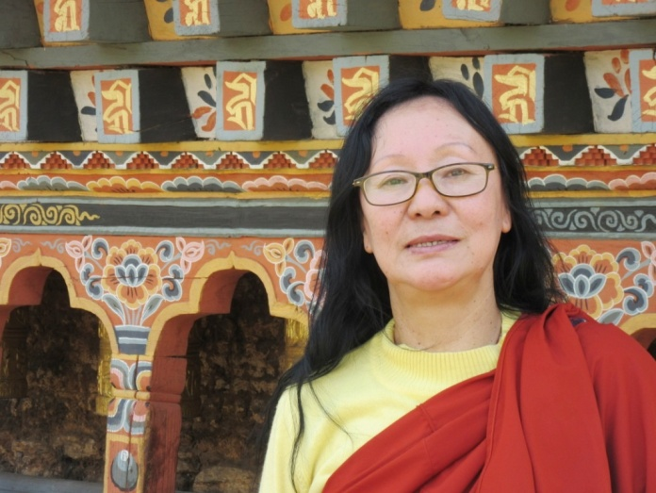

Draktsho is a pioneer in the country in the field of disability, we strongly feel responsible to tend to the need of people living with disabilities specially the children and youth who need to be guided and provided with educational, vocational and life skill training. Draktsho feels responsible to remove barriers they might face other-wise relating to accessing educational and vocational training services.

Providing services to the persons with disabilities involves huge financial resources and Draktsho has been continuously striving towards achieving financial self-reliance to support the children and youth with disabilities across the country. In order to achieve this goal, Draktsho has been trying to incorporate activities like farming and handicraft production etc. over the last few years; we are continuously researching for areas to sustain our activities.

The COVID-19 pandemic in 2020 has resulted in collapse of many businesses and institutions. Draktsho relies heavily on foreign visitors and donors to finance its activities. With the ban on travel in and out of country, one of Draktsho’s main sources of income has been completely undermined. However, with the protection and support from our guardian His Majesty the King, our people have been saved. I cannot find enough words to express our gratitude to our King for his concern and continuous work to save his people and country from the Pandemic. We the people of Bhutan are blessed to have a Noble King like Jigme Khesar Namgyel Wangchuck.

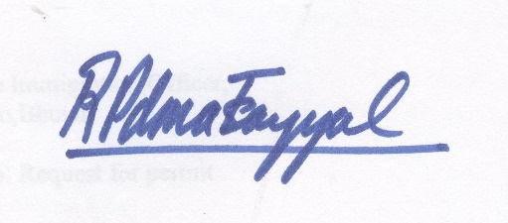

Rigzin Padma Tsogyal

Founder & Director

Draktsho

**Draktsho**

**History:**

Draktsho previously known as Drak-Tsho Vocational Training Centre for the Disabled (DVTCD) is now known as Draktsho Vocational Training Centre for Special Children and Youth or simply Draktsho. Draktsho is a combination of two Dzongkha words “Drak” and “Tsho” meaning “Cliff or high mountain” and “sea or ocean” respectively. Put together, Draktsho is supposed to describe the height and the depth of its goals and aspirations. Draktsho is supposed to signify its aspiration as high as the mountain and its commitment as deep as the ocean in the service of children and youth with disabilities. Draktsho strongly believes that everybody has the right to be independent and equal, has the power to choose, and to live their lives to the fullest potential. Disability is prevalent and affects all age groups. Although attitudes towards people with disabilities and other minority groups within our society are changing and becoming more positive, there still seems to be an immense lack of understanding about disability as “disadvantaged individuals” whose disabilities cause “suffering.” It is the environment that imposes constraints preventing persons with disabilities from running their lives in a way equal to persons with disabilities.

After 10 years of operation, Draktsho was finally registered as a CSO on 26th November 2010. Draktsho is the first of its kind in the country; it’s a service- oriented and Public Benefit Organization under the Civil Society Organization Act of Bhutan which aspires to enhance the living standard of children and youth with various types of disabilities through empowerment by training, education and eventual integration with the mainstream population.

## Vision

## “Persons with Disabilities in Bhutan will actively and equitably participate in socio-economic development of the country and live a fulfilling life”

## Mission

“*To ensure young Persons with Disabilities in Bhutan have quality opportunities for developing skills for life and vocation, and for becoming self-reliant, make a living and lead a contended life overcoming barrier created by gender or other differences”*

**Goals**

1. Draktsho will be a centre of excellence in Bhutan providing state of the art training and supportive services for vocational training, employment and quality living for persons with disabilities.
2. Draktsho will work with all different kinds of special needs children and youth, with special focus on children/ youth with intellectual impairments.
3. Draktsho will work with children/youth and adults with disabilities and their families.
4. Draktsho will be proactive in promoting equal work opportunities for persons with disabilities keeping in view the employment scenario for youth in Bhutan.
5. Draktsho will be a model activity-based program, generating concepts and methods for promoting employment for persons with disabilities that can be adopted by similar services in urban and rural areas of Bhutan.
6. Draktsho will adopt approaches and methods that foster and reflect inclusion.
7. Draktsho will develop as a facilitator and a technical resource base for promoting employment of persons with disabilities.

## Our main objectives are:

1. To provide training in life skills including basic literacy and numeracy to persons with special needs for enabling them to cope with their daily life needs in present and future.
2. To equip trainees with special needs with vocational and work skills as preparation for sheltered, open or self-employment.
3. To facilitate the trainees with special needs secure work with dignity.
4. To initiate dialogue, build collaborations and networks with different stakeholders (government, industry, institutions etc.) for actively promoting equal opportunities for people with special needs.
5. To organize parent support and community outreach program for raising awareness and generating support for inclusion of persons with special needs.
6. To conduct training, research and documentation for building human resources, supporting innovative actions and generating resource material and data for supporting quality services and advocacy.

**Teachers Day Celebration**

2nd May is observed as the birth anniversary of Third Druk Gyalpo Jigme Dorji Wangchuck which is also celebrated as The Teachers Day. Draktsho East Centre observed this auspicious day with prayers and offering of butter lamps followed by speeches delivered by the students showing their gratitude towards teachers. The students performed a variety of cultural programs such as mask dances, stage shows which was followed by teachers performing solo songs.

This beautiful day ended with everyone having lunch together. The occasion was graced by the Lopen of Kanglung Shedra.

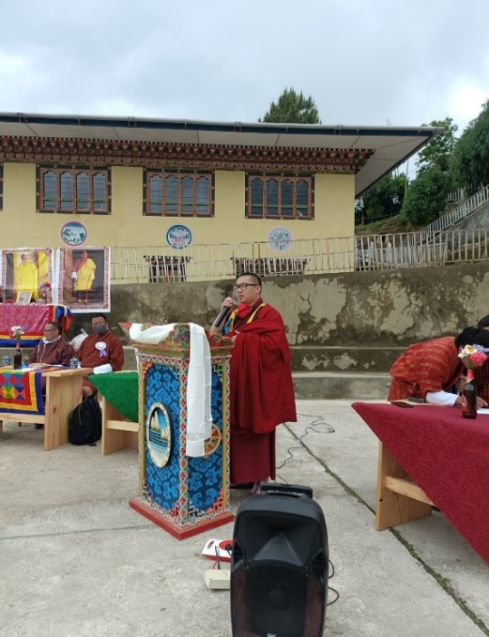 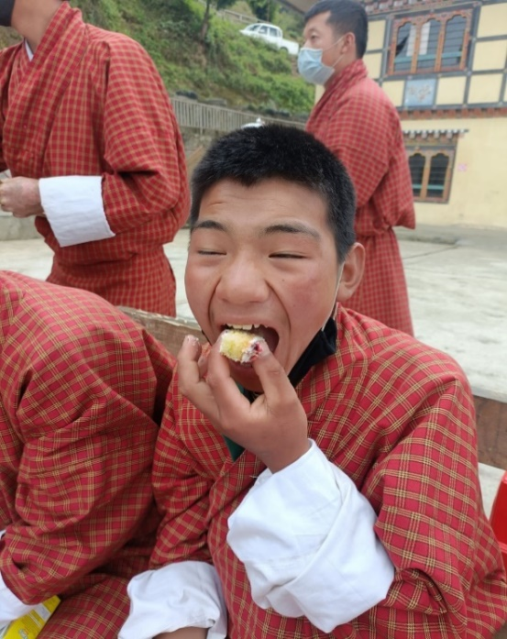

**20th May**

RENEW with support from [**IPPF, South Asia Region**](https://www.facebook.com/IPPFSAR?__cft__%5b0%5d=AZVK0F5rP4nJSMgoZGVwhdEqch-WxXnV9dzmXQy8gQvZ6BFT4LStdN5-620uqt95KTs8AmngKaqSPDbJDd-D_F1-rmI_BUVmaneCLLOQCX2n6oP2YRsQroZrNoolHlshG2ch8rE3Nf0OMZ7IBqHN-JxqljW6qdxoeuXA4ocGiLE0wmoCKl_NfbaLpDKQZicF9u4sTvq60czZjYLLgX619qjwOfB1jzVZOZN1U1M-9itPkQ&__tn__=-%5dK-y-R) conducted a workshop on the 15th of May at RENEW office with 6 students from [**Draktsho Vocational Training Centre For Special Children and Youth**](https://www.facebook.com/groups/141720405875702/?__cft__%5b0%5d=AZVK0F5rP4nJSMgoZGVwhdEqch-WxXnV9dzmXQy8gQvZ6BFT4LStdN5-620uqt95KTs8AmngKaqSPDbJDd-D_F1-rmI_BUVmaneCLLOQCX2n6oP2YRsQroZrNoolHlshG2ch8rE3Nf0OMZ7IBqHN-JxqljW6qdxoeuXA4ocGiLE0wmoCKl_NfbaLpDKQZicF9u4sTvq60czZjYLLgX619qjwOfB1jzVZOZN1U1M-9itPkQ&__tn__=-UK-y-R)

The workshop was conducted with the sole purpose of:-

1) To create awareness among vulnerable youth groups of Bhutan.

2) To brainstorm and develop creative and expressive advocacy materials to showcase their ideas and concerns on the subject matter. Which will be then displayed at the Youth conclave at the Royal Thimphu College

The conclave on 25th of May will be a platform for a cross-section of youth to meet with each other and exchange ideas, share learning, engage with media and government officials to generate conversations, and develop further advocacy objectives for SRHR.

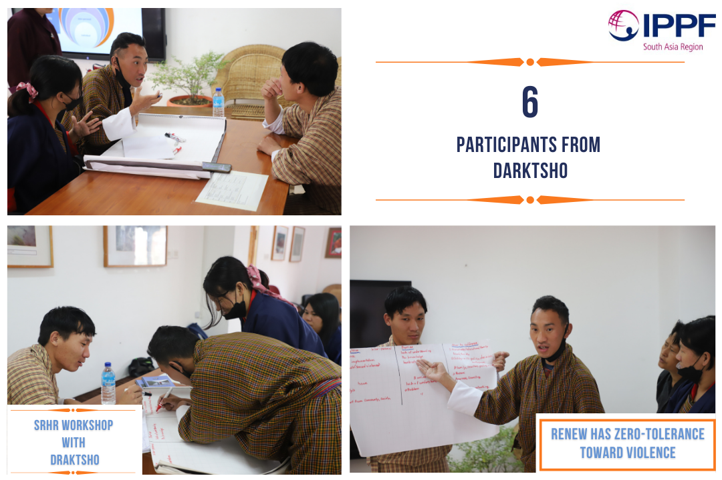

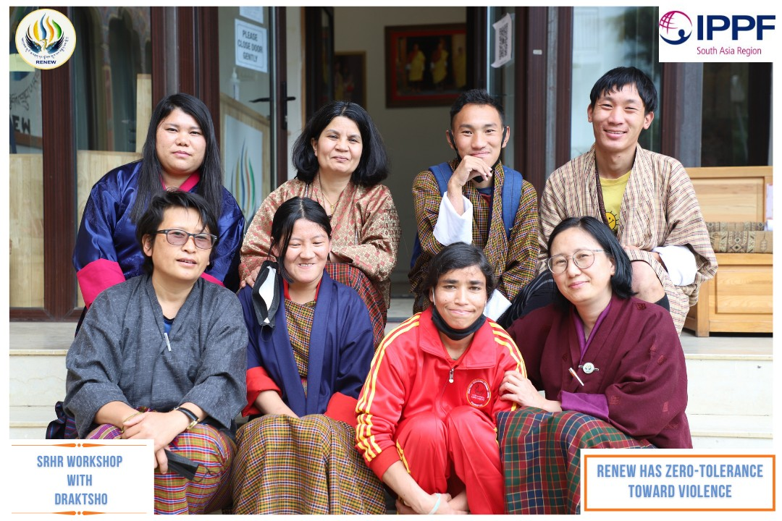

**2nd June**

Draktsho celebrated the occasion of the Coronation Anniversary of our beloved Fourth Druk Gyalpo and Social Forestry Day by planting 50 numbers of seedlings in the area above Sangaygang and plantation drive was made possible with support of saplings from Green Bhutan Corporation Limited as a part of their CSR program. We would like to humbly offer our prayers and good wishes for the long life of His Majesty The Fourth Druk Gyalpo and the continued flourishing of the Kingdom of Bhutan under the eternal stewardship of the Kings.

On the other hand Draktsho East planted 300 tree saplings around the premises of Draktsho East Center contributing to conservation of nature.

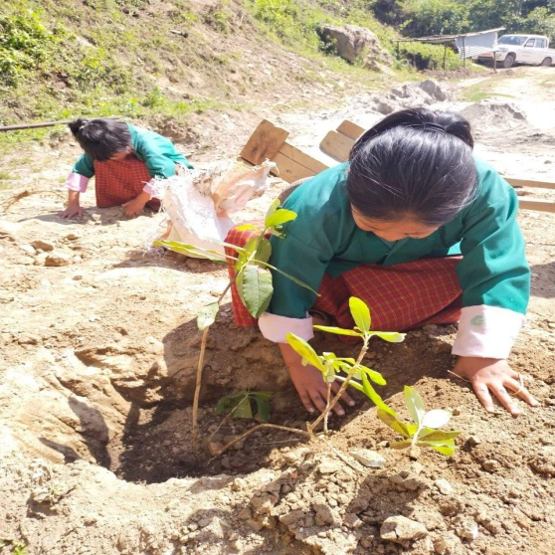 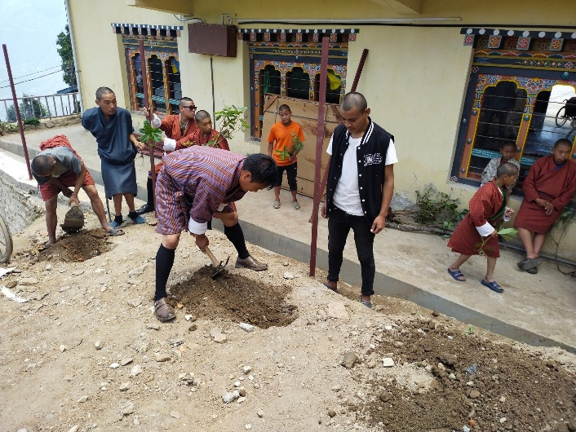

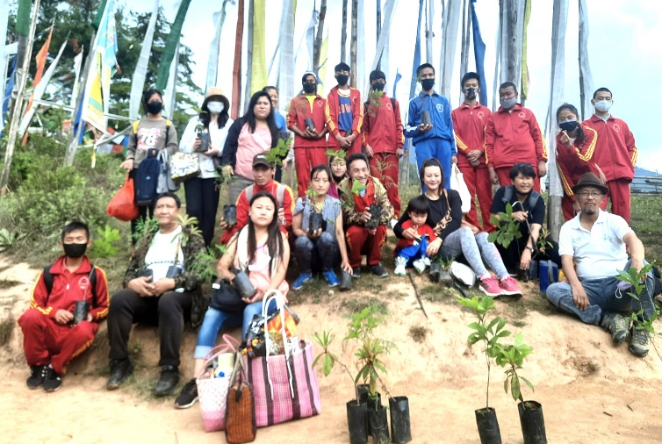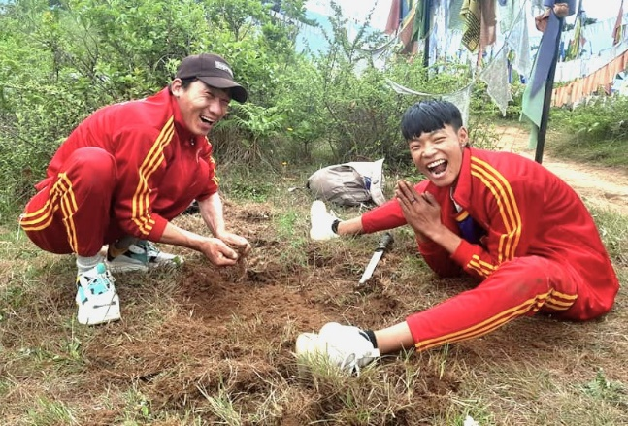

**Donations for the year**

Draktsho has received vocational training materials support from [**Opening Your Heart To Bhutan**](https://www.facebook.com/openingyourhearttobhutan?__cft__%5b0%5d=AZVkyytin3ASzymA6i-EMoOLUJ-iIBcIbjdGnESdYUkItNx4xNmH9S8sMZ_3His0EhqIJ5Gn61hm5MljiAXpOl25aBbp0PYTCwhihgg_aU0l6bmr5WnXI_BuF_bEBpp6TZSp-DiaGjGTZ2lpjf6M2Xqdhj1hEDC93koLgBk1JWKrLp7U0Xq1pvffROk93HxoJuc&__tn__=-%5dK-R), a charitable organization that has made it possible for us to continue our work of empowering students with disabilities through vocational and skills training. We are immensely grateful for the unwavering commitment that Opening Your Heart to Bhutan has demonstrated towards our cause.

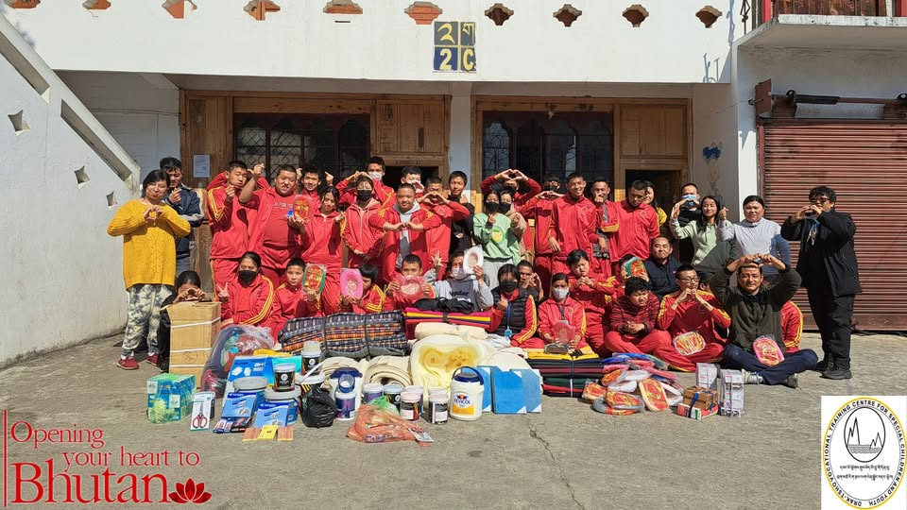

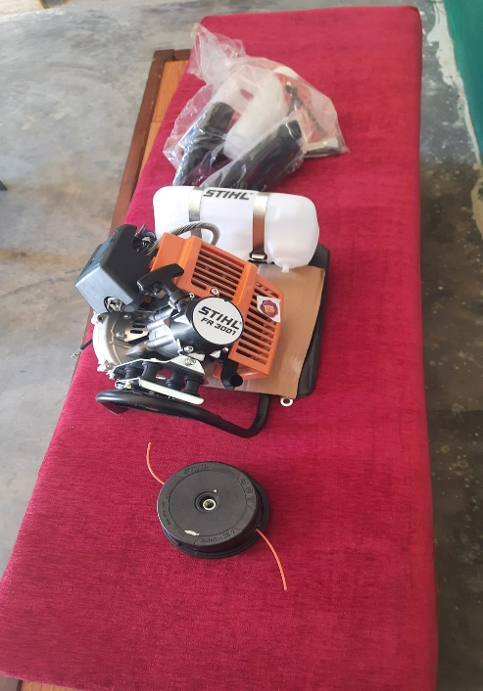

Draktsho is also grateful towards Mr Daniele Dossi from Spain for donating a Grass cutting machine for Draktsho East Centre. This equipment has made the manual work a lot easier for the students and Mr. Daniele has always been one of Draktsho’s well wishers over the years.

It was a big task to build all the library insides and stock with books but with your help opening your heart to Bhutan made it! Thanks so much everyone [**Daniele Dossi**](https://www.facebook.com/daniele.dossi.1?__cft__%5b0%5d=AZXRNJiX-F4w3uW_o6Vi_tSWHcqaBgHmBZsJdD50ahnImubOkcCO4XmcxfcUwWLPWaVx6Vzo0CU5bHCz2SD7_JEFyN7AaLgw_72rZohUxChLLq66nwKgLd0HlLG33BMRKNN5SAuCRusjxU-Em_JtGaUu1ZleCtspAUl0eRXiOD257dCDXJnfTybIlLEPDhJKoBE&__tn__=-%5dKH-R) [**Bridget Simmonds**](https://www.facebook.com/bridget.simmonds.96?__cft__%5b0%5d=AZXRNJiX-F4w3uW_o6Vi_tSWHcqaBgHmBZsJdD50ahnImubOkcCO4XmcxfcUwWLPWaVx6Vzo0CU5bHCz2SD7_JEFyN7AaLgw_72rZohUxChLLq66nwKgLd0HlLG33BMRKNN5SAuCRusjxU-Em_JtGaUu1ZleCtspAUl0eRXiOD257dCDXJnfTybIlLEPDhJKoBE&__tn__=-%5dKH-R) [**Sue Hills**](https://www.facebook.com/sue.ward.500?__cft__%5b0%5d=AZXRNJiX-F4w3uW_o6Vi_tSWHcqaBgHmBZsJdD50ahnImubOkcCO4XmcxfcUwWLPWaVx6Vzo0CU5bHCz2SD7_JEFyN7AaLgw_72rZohUxChLLq66nwKgLd0HlLG33BMRKNN5SAuCRusjxU-Em_JtGaUu1ZleCtspAUl0eRXiOD257dCDXJnfTybIlLEPDhJKoBE&__tn__=-%5dKH-R) [**Peter Williams**](https://www.facebook.com/peter.williams.737?__cft__%5b0%5d=AZXRNJiX-F4w3uW_o6Vi_tSWHcqaBgHmBZsJdD50ahnImubOkcCO4XmcxfcUwWLPWaVx6Vzo0CU5bHCz2SD7_JEFyN7AaLgw_72rZohUxChLLq66nwKgLd0HlLG33BMRKNN5SAuCRusjxU-Em_JtGaUu1ZleCtspAUl0eRXiOD257dCDXJnfTybIlLEPDhJKoBE&__tn__=-%5dKH-R) [**Karin van Maanen**](https://www.facebook.com/karin.vanmaanen.1?__cft__%5b0%5d=AZXRNJiX-F4w3uW_o6Vi_tSWHcqaBgHmBZsJdD50ahnImubOkcCO4XmcxfcUwWLPWaVx6Vzo0CU5bHCz2SD7_JEFyN7AaLgw_72rZohUxChLLq66nwKgLd0HlLG33BMRKNN5SAuCRusjxU-Em_JtGaUu1ZleCtspAUl0eRXiOD257dCDXJnfTybIlLEPDhJKoBE&__tn__=-%5dKH-R) [**Lisa Milnor**](https://www.facebook.com/lisa.milnor?__cft__%5b0%5d=AZXRNJiX-F4w3uW_o6Vi_tSWHcqaBgHmBZsJdD50ahnImubOkcCO4XmcxfcUwWLPWaVx6Vzo0CU5bHCz2SD7_JEFyN7AaLgw_72rZohUxChLLq66nwKgLd0HlLG33BMRKNN5SAuCRusjxU-Em_JtGaUu1ZleCtspAUl0eRXiOD257dCDXJnfTybIlLEPDhJKoBE&__tn__=-%5dKH-R) [**Pema Deki**](https://www.facebook.com/pema.deki.5209?__cft__%5b0%5d=AZXRNJiX-F4w3uW_o6Vi_tSWHcqaBgHmBZsJdD50ahnImubOkcCO4XmcxfcUwWLPWaVx6Vzo0CU5bHCz2SD7_JEFyN7AaLgw_72rZohUxChLLq66nwKgLd0HlLG33BMRKNN5SAuCRusjxU-Em_JtGaUu1ZleCtspAUl0eRXiOD257dCDXJnfTybIlLEPDhJKoBE&__tn__=-%5dKH-R) [**Gepco van Bokhorst**](https://www.facebook.com/gepco.vanbokhorst?__cft__%5b0%5d=AZXRNJiX-F4w3uW_o6Vi_tSWHcqaBgHmBZsJdD50ahnImubOkcCO4XmcxfcUwWLPWaVx6Vzo0CU5bHCz2SD7_JEFyN7AaLgw_72rZohUxChLLq66nwKgLd0HlLG33BMRKNN5SAuCRusjxU-Em_JtGaUu1ZleCtspAUl0eRXiOD257dCDXJnfTybIlLEPDhJKoBE&__tn__=-%5dKH-R). Draktsho is grateful to all these donors for supporting help set up a Library Section at Draktsho East Centre.

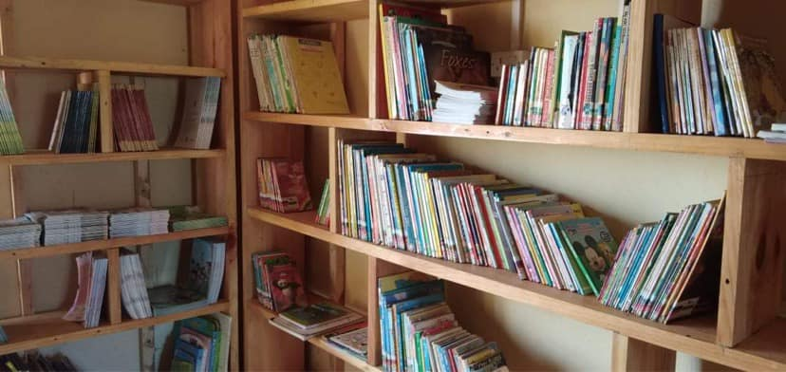

**Cerebral Palsy Day**

World Cerebral palsy day on 6th October was created by the cerebral palsy alliance in 2012 and now brings together people living with cerebral palsy, their families, allies, supporters and organization’s across more than 100 countries. All with the aim to ensure a future in which children and adults with cerebral palsy have the same rights, access and opportunities as anyone else in our society.

The theme “Millions of Reasons” highlights that there are 17 million people all over the world who are suffering from the cerebral palsy disorder. The day also emphasizes crating awareness about disability by coming together to celebrate and support those living with cerebral palsy, embrace diversity and to help create more accessible future for everyone.

We at Draktsho observed this day by calling together students, parents, teachers and volunteers to participate in art competitions, playing games, singing and dancing which ended with lunch and snacks. This event concluded with so much happiness, joy and laughter.

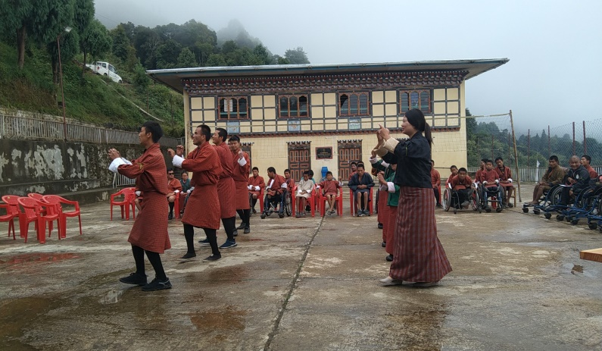

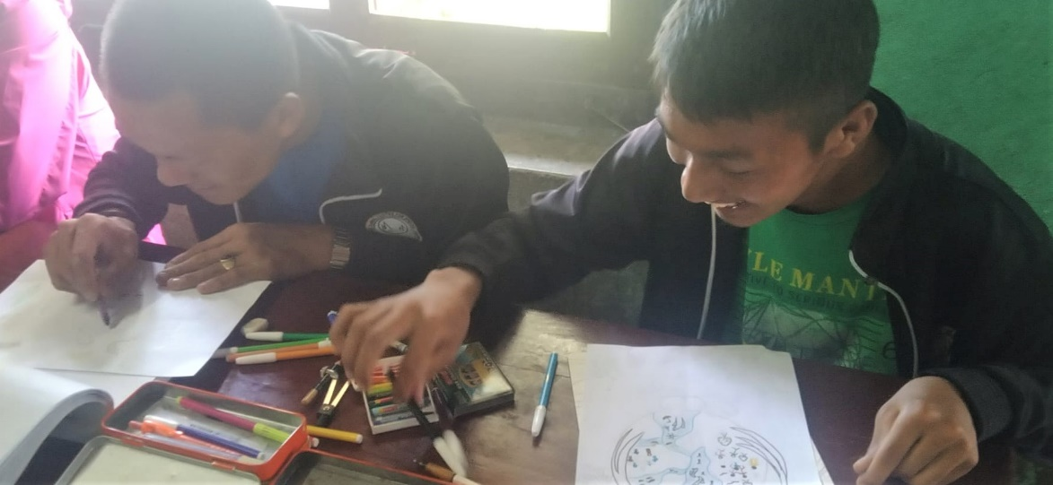

Draktsho in collaboration with DANTAK Kanglung conducted a general health checkup for the students and also the staffs. The team was led by Lt Col (Dr.) Mohan Sharma (DADMS, HQ DANTAK) and Mr. Arnab Chakraborty (OC, Kanglung DANTAK). This is one of the main events that is conducted for the students and staffs annually with in collaboration with JDWNRH or DANTAK.

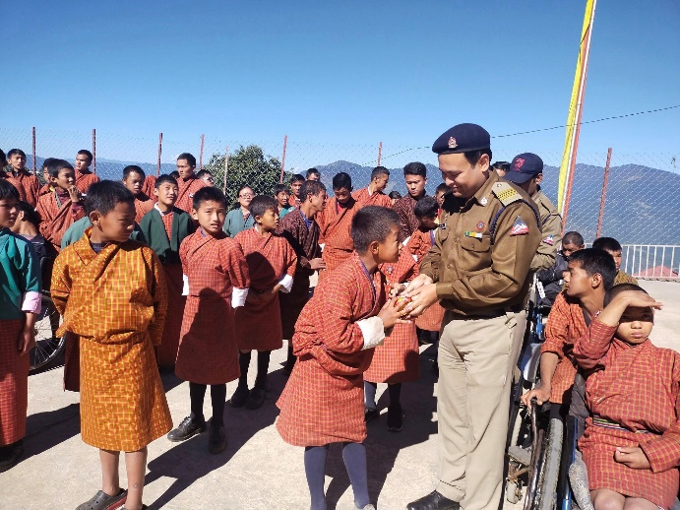 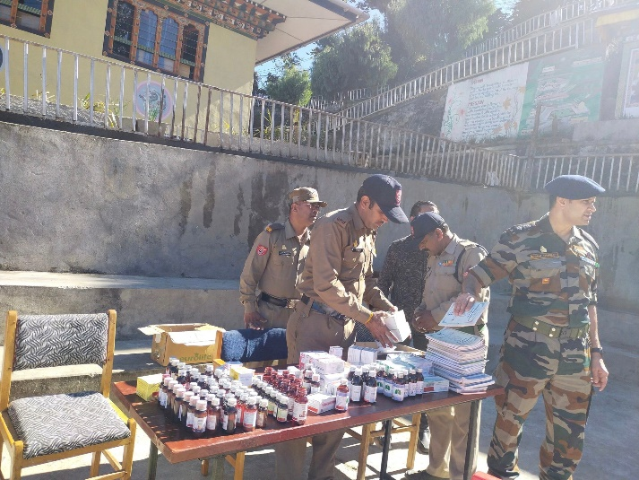

**International Peace Day**

**The International Day of Peace** (“Peace Day”) is observed around the world each year on 21 September. Established in 1981 by unanimous United Nations resolution 36/37, the General Assembly has declared this as a day devoted to ***“commemorating and strengthening the ideals of peace both within and among all nations and peoples.”***

**Draktsho in collaboration with UNDP also joined the world in celebrating this day by organizing an Art competition amongst the students focusing on the theme for 2022, “End Racism. Build Peace”. Three winners were selected and awarded cash prizes by UNDP Bhutan.**

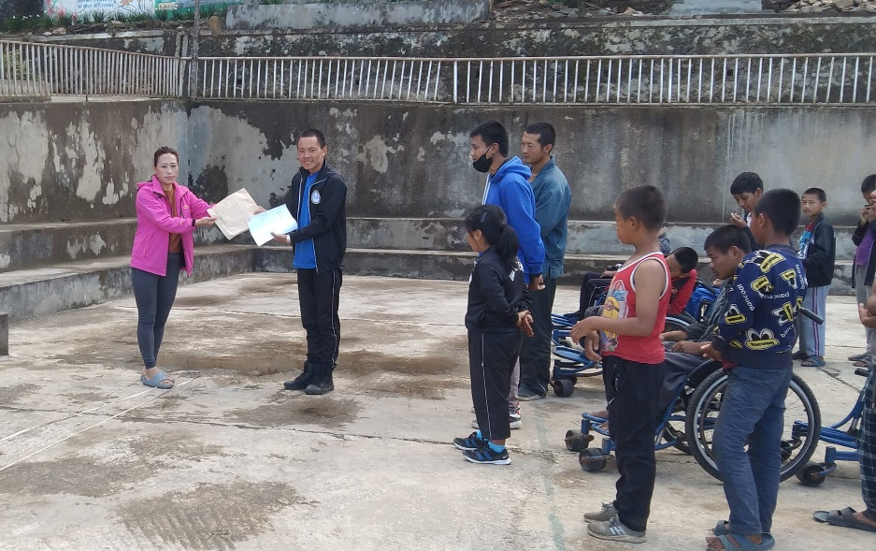

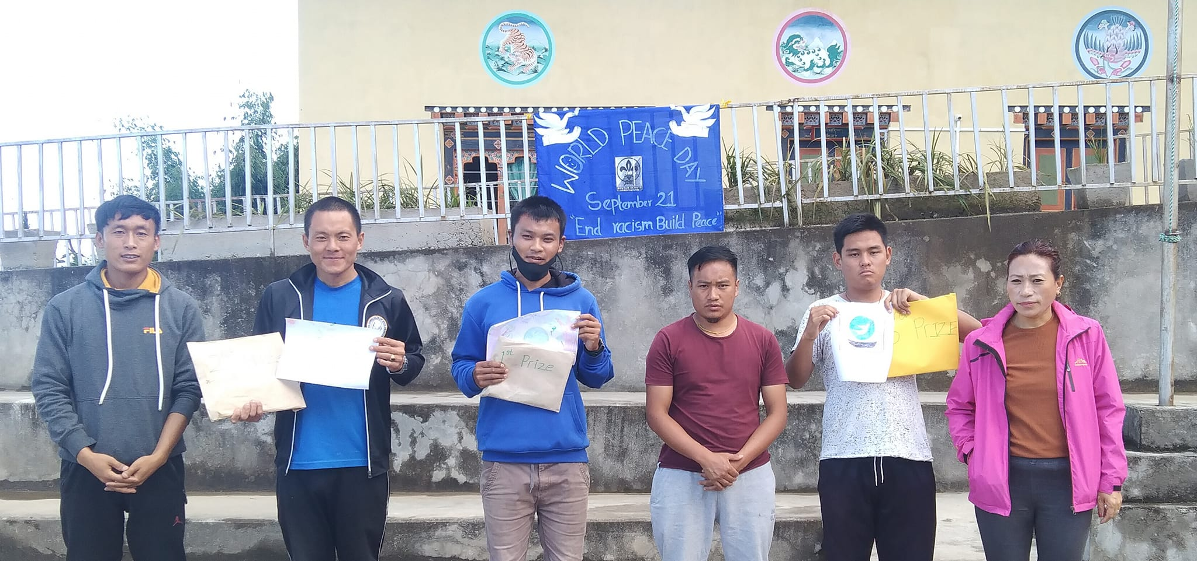

**International Day of Persons with Disabilities**

3rd December is observed as the International Day of Persons with disabilities globally and Draktsho also observes this day annually at both the centres. Draktsho Thimphu organized a sports competition where athletes with disabilities participated in Olympic type of sports showcasing the talents of athletes. Other fun games were also included so everyone could take part and enjoy equally irrespective of age, gender or disability. Parents, teachers, athletes and volunteers came together to celebrated this special day. Cash prizes with certificates were awarded to all the winners which also included consolation prizes for athletes with severe disabilities.

On the other end at Draktsho East students and teachers observed the day spiritually as one of the holy priests known as His Eminence Zuri Rinpoche spent the day with them. HE Zuri Rinpoche awarded cash incentives, socks and shoes to all the students and also blessed them celebrating his masters 91st birthday coinciding with the International day of Persons with Disabilities. 10 students from Draktsho East were also selected to act in one of Rinpoches short documentary films that was based on cremation and afterlife.

Rinpoche has been supporting the students of Draktsho East for many years.

